**FACIAL FEATURE DETECTION**

***Rishabh Kamath***

Data Scientist

**Inference Labs**

**Introduction.**

Facial feature detection is a computer vision and image processing approach that identifies and localizes certain facial characteristics on human faces in digital pictures or video frames. These characteristics commonly include, but are not limited to, the eyes, nose, mouth, brows, and, on occasion, additional landmarks such as the chin or ears. The basic purpose of facial feature detection is to properly find and differentiate these traits within an image, enabling a variety of applications such as face recognition, emotion analysis, augmented reality, and others.

Because of its function in powering many computer vision applications, face feature recognition has gained in relevance in recent years. In the context of face recognition, recognizing certain traits enables algorithms to correctly compare and verify identities. The exact recognition of facial features can help emotion analysis systems infer emotions and expressions. The recognition of face characteristics in augmented reality allows for the precise overlay of virtual items on real-world photos.

The purpose of this documentation is to investigate the methodologies, strategies, and processes involved in facial feature identification, offering insights into its implementation, applications, obstacles, and potential future enhancements. Readers will have a thorough knowledge of how facial feature detection works and how it may be implemented in a variety of real-world circumstances.

**Methods and Techniques.**

Facial feature detection primarily utilizes an object detection approach, leveraging carefully annotated images that serve as training data. In this approach, images of human faces are annotated to mark the positions and boundaries of specific facial features, including but not limited to the nose, eyes, eyebrows, and mouth. These annotations provide ground-truth information, guiding the machine learning or computer vision model during the training process.

The annotated images serve as a valuable resource for teaching the model to recognize and differentiate between various facial features. The model learns to identify the unique patterns and characteristics associated with each feature. This process involves extracting relevant features from the images, such as shapes, edges, and textures, which are essential for accurate feature detection.

Object detection techniques, such as convolutional neural networks (CNNs), are commonly employed to analyze and process the annotated images. These techniques enable the model to identify regions of interest within an image that likely correspond to specific facial features. During the training phase, the model refines its understanding of these features by adjusting its internal parameters based on the annotated data.

Once trained, the model can be applied to new, unseen images to detect and localize facial features accurately. This approach provides the foundation for a wide range of applications, from facial recognition systems that verify identities to augmented reality experiences that rely on precise feature detection to overlay virtual elements seamlessly onto real-world images. The accuracy and reliability of these applications depend significantly on the effectiveness of the object detection approach and the quality of the annotated training data.

When it comes to facial feature detection, a variety of methods and techniques are employed to ensure precise and reliable results. The process involves a range of elements, including preprocessing steps and data augmentation techniques, tailored to the unique characteristics of the task.

1. **Use of Pre-trained Models:** Many facial feature detection applications benefit from the use of pre-trained models, with YOLO being the key models utilized in our approach. These pre-trained models, often trained on large datasets, can provide a significant head start in the training process for facial feature detection. They capture a wide range of features and patterns that are not only useful but also essential for the task of locating facial features accurately.

**YOLO v8 (You Only Look Once, Version 8):** YOLO v8 is a renowned real-time object detection system known for its speed and precision. In our approach, we employed YOLO v8 to detect specific facial features, such as the eyes, nose, eyebrows, and mouth. The model was trained and fine-tuned separately on annotated datasets to recognize these features accurately. YOLO v8's real-time detection capability is advantageous for applications requiring timely responses.

1. **Preprocessing and Augmentation of images:** In the context of facial feature detection, a variety of methods and techniques were employed to ensure precise and reliable results. The process involved a comprehensive range of elements, reflecting the intricate nature of the task. Key components included preprocessing steps that encompassed converting images into grayscale, thereby reducing color information to emphasize structural details, and introducing controlled levels of blur to reduce image noise and enhance feature saliency. Additionally, data augmentation techniques played a pivotal role in the preparatory phases of the task. These encompassed the deliberate introduction of variations into the dataset, such as rotations, scaling, and mirroring, to enhance the model's robustness and its ability to generalize well to different facial structures and lighting conditions. By subjecting the dataset to such transformations, the model was better equipped to handle variations in real-world images and was less prone to overfitting. This comprehensive approach, which incorporated preprocessing steps and data augmentation, was instrumental in developing a facial feature detection system capable of achieving high precision and adaptability across diverse applications.

**Approach.**

In our approach to facial feature detection, we adopted a multi-faceted strategy to ensure the accuracy and reliability of the system. This involved the utilization of both the DLib library and manual data annotation.

* **DLib Library:** We harnessed the capabilities of the DLib library, a well-regarded tool for facial feature detection and landmark localization. DLib offers pre-trained models for facial feature detection, making it a robust resource for rapidly identifying features such as the eyes, nose, and mouth. One notable aspect of our approach involved converting these facial landmarks into bounding boxes, effectively auto-annotating the images. This transformation aimed to facilitate the process of defining feature regions for the model.

However, it's important to acknowledge the challenges that arose during this conversion process. Scaling the bounding boxes correctly proved to be a complex task, as improper scaling could lead to inaccuracies in feature annotations. In some cases, the bounding boxes did not align optimally with the features they were meant to encapsulate, affecting the precision of the annotations. This necessitated meticulous adjustment and fine-tuning to ensure the bounding boxes accurately represented the facial features in the images.

In addition to the conversion of facial landmarks, we also explored manual data annotation as a complementary approach. This meticulous process involved annotating images to mark the positions and boundaries of specific facial features, such as the eyes, nose, and eyebrows. Manual annotation allowed us to create a custom dataset tailored to our project's requirements, ensuring the precision and accuracy of the detected features.

* **Manual Data Annotation:** In addition to using pre-trained models, we conducted manual data annotation, a meticulous process that involved the precise annotation of images to delineate the positions and boundaries of specific facial features, such as the eyes, nose, and eyebrows. To achieve this, we employed a tool called Roboflow, which enabled us to draw bounding boxes over each of the facial features.

Roboflow played a crucial role in the annotation process, facilitating both manual and auto-annotation tasks. While manually annotating images, we used the tool to draw accurate bounding boxes around each feature, ensuring that the annotations aligned with the true positions of the facial landmarks. This process was instrumental in creating a custom dataset meticulously tailored to our project's requirements. Additionally, Roboflow’s auto-annotation capabilities offered an efficient means of annotating a large volume of images, optimizing the overall annotation workflow. The tool leveraged its capabilities to automatically generate annotations for specific facial features, streamlining the dataset preparation process. The combination of manual and auto-annotation using Roboflow played a pivotal role in ensuring the precision and accuracy of the detected features, contributing to the success of our facial feature detection system.

**Training.**

We divided the training process into three iterative phases to achieve optimal results.

**First Iteration (100 Images):** In the initial phase, we started with a limited dataset of 100 annotated images. This served as the foundation for training and fine-tuning the model to detect facial features accurately.

**Second Iteration (400 Images):** Building upon the insights gained from the first iteration, we expanded the dataset to 400 images. This larger dataset allowed for a more robust and refined training process.

**Third Iteration (1000 Images with Augmentations):** For the final iteration, we significantly increased the dataset size to 1000 images, while also incorporating data augmentation techniques. These augmentations included rotations, scaling, and mirroring, effectively increasing the dataset to 2000 images. The introduction of augmentations enhanced the model's adaptability to variations in real-world images and contributed to its robustness.

By progressing through these iterations, our approach ensured that the model was fine-tuned to accurately locate facial features, making it well-equipped to handle various scenarios and achieve a high level of precision and reliability in facial feature detection.

**Results.**

**Evaluation Metrics:**

The evaluation metrics are a critical component of our facial feature detection system, serving as benchmarks to assess the system's accuracy and reliability in detecting specific facial features. These metrics provide a comprehensive understanding of our model's performance in differentiating and localizing key facial features. The following results are validated on 149 validation set images

**Class-wise Analysis:**

* **"all" Class:**
  + **Precision (0.823):** Precision measures the percentage of correctly identified instances. In the "all" class, our system achieves a precision of 0.823, indicating that approximately 82.3% of the detected facial features are accurate.
  + **Recall (0.848):** Recall quantifies the system's ability to detect actual instances. In this case, the recall of 0.848 indicates that our system successfully identifies 84.8% of the real facial features.
  + **F1-Score (0.864):** The F1-Score is a balanced measure that combines precision and recall. In the "all" class, it stands at 0.864, reflecting the overall accuracy and reliability of our system.
* **"face" Class:**
  + **Precision (0.99):** The "face" class exhibits exceptional precision, with 99% of detected faces being correct. This demonstrates the system's high accuracy in identifying facial structures.
  + **Recall (1):** A recall of 1 indicates that our system successfully identifies all actual faces.
  + **F1-Score (0.995):** The high F1-Score of 0.995 highlights the system's ability to maintain both high precision and recall.
* **"left_eye" and "right_eye" Classes:**
  + **Precision (0.73):** Precision values of approximately 0.73 for both "left_eye" and "right_eye" classes show that a substantial portion of the detected eye features are accurate.
  + **Recall (0.72 to 0.77):** Recall values ranging from 0.72 to 0.77 indicate the system's ability to successfully detect a significant portion of the actual eye instances.
  + **F1-Scores (0.579 to 0.597):** The F1-Scores, ranging from 0.579 to 0.597, reflect a balanced performance of the system in detecting eyes.
* **"left_eyebrow" and "right_eyebrow" Classes**:
  + **Precision (0.67 to 0.73):** Precision values between 0.67 and 0.73 for the eyebrow classes indicate that a substantial portion of the detected eyebrows is correct.
  + **Recall (0.74 to 0.77):** Recall values between 0.74 and 0.77 suggest that our system successfully detects a significant portion of the actual eyebrow instances.
  + **F1-Scores (0.489 to 0.518):** F1-Scores, ranging from 0.489 to 0.518, represent the balance between precision and recall in eyebrow detection.
* **"mouth" Class:**
  + **Precision (0.97):** High precision (0.97) indicates that most of the detected mouth instances are accurate.
  + **Recall (0.973):** A recall of 0.973 highlights the system's successful detection rate for mouth instances.
  + **F1-Score (0.991):** The F1-Score of 0.991 reflects the system's strong overall performance in detecting mouths.
* **"nose" Class:**
  + **Precision (1):** The highest possible precision score (1) indicates that all detected instances of the nose are correct.
  + **Recall (0.998):** Recall close to 1 (0.998) means that our system successfully detects nearly all actual noses.
  + **F1-Score (0.995):** The F1-Score of 0.995 signifies a high level of accuracy and reliability in nose detection.

**Speed Analysis:**

The speed analysis is crucial for real-time applications and offers insights into the efficiency and responsiveness of the system. It provides timing data for different stages, which is measured in milliseconds per image:

* **Preprocessing (3.8ms):** Preprocessing encompasses any image preparation tasks before detection. The system spends 3.8 milliseconds on these tasks per image.
* **Inference (21.0ms):** Inference is the core detection process. The system dedicates 21.0 milliseconds per image to perform inference and identify facial features.
* **Loss Calculation (0.0ms):** The loss calculation stage takes negligible time, indicating that the model's loss function computation is highly efficient.
* **Post-processing (8.8ms):** Post-processing activities, such as refining detections and drawing bounding boxes, consume 8.8 milliseconds per image.

This speed analysis data is valuable for assessing the system's real-time capabilities and can be particularly useful for applications that require timely responses, such as facial recognition.

In summary, the evaluation metrics and speed analysis collectively provide a comprehensive picture of our facial feature detection system's performance. These results demonstrate the high quality and accuracy of our system in differentiating and localizing specific facial features. The combination of precise detection and efficient processing makes our system well-suited for a wide range of applications, from facial recognition to real-time analysis.

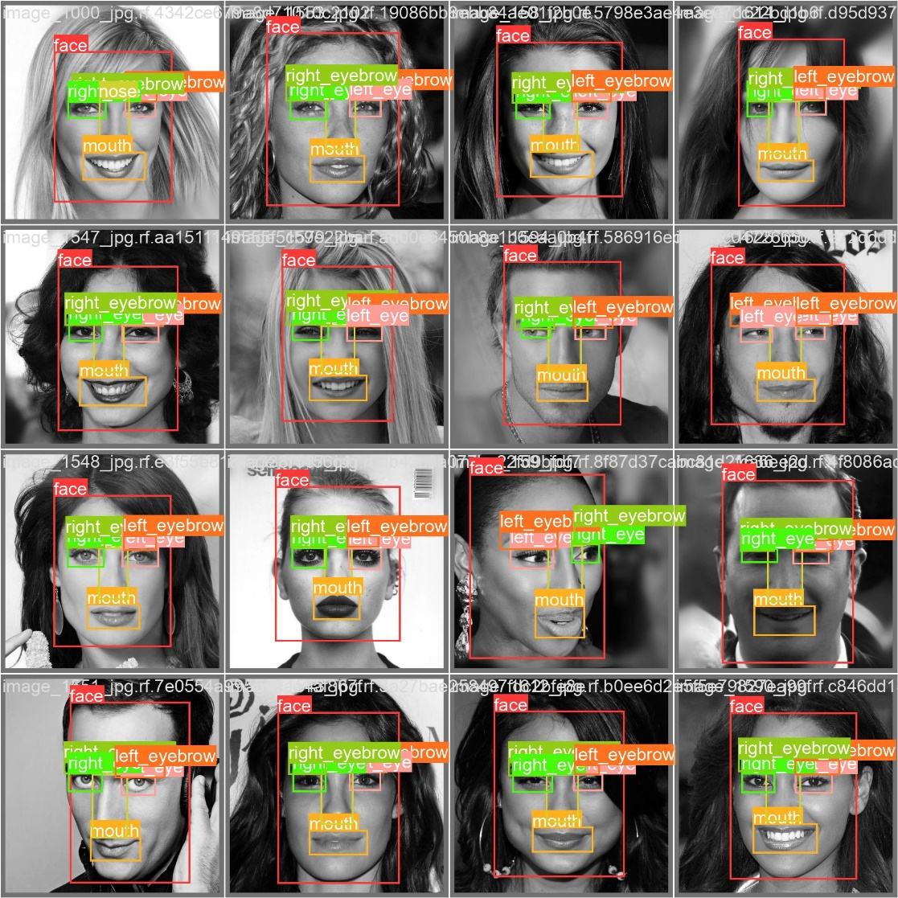

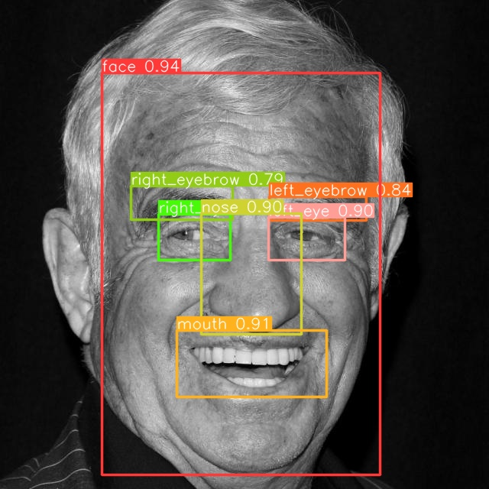 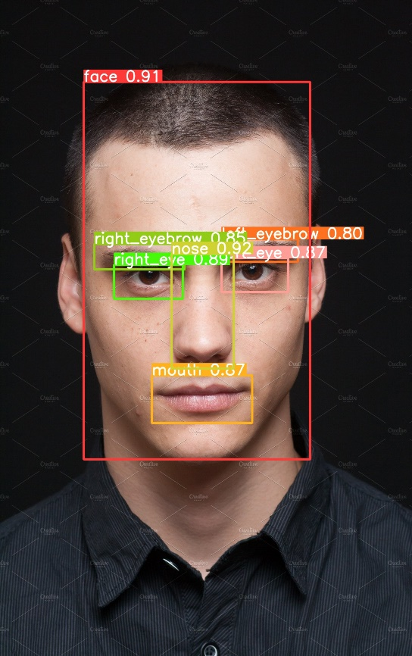

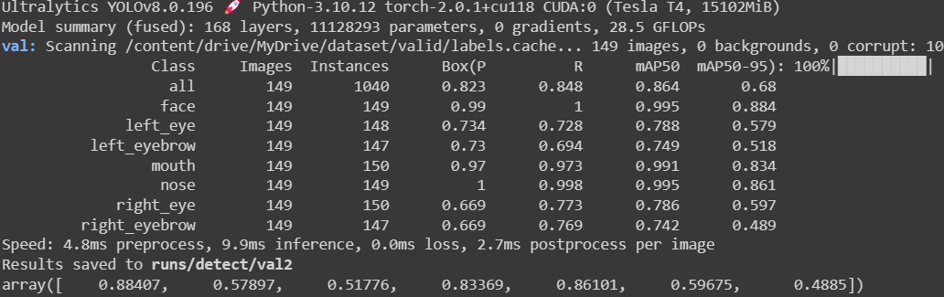

**Confusion matrix**

**Positive Aspects:**

High Accuracy for Face and Background Classes: The model excels in predicting "face" and "background" classes, which are common and critical features in the images. This is evident in its high precision, recall, and overall accuracy for these classes.

**Challenges:**

Struggles with Specific Classes: The model faces difficulties when predicting classes like "left eye," "right eye," "eyebrows," "mouth," and "nose." Precision and recall for these classes are comparatively lower, indicating the need for improvement in differentiating these features

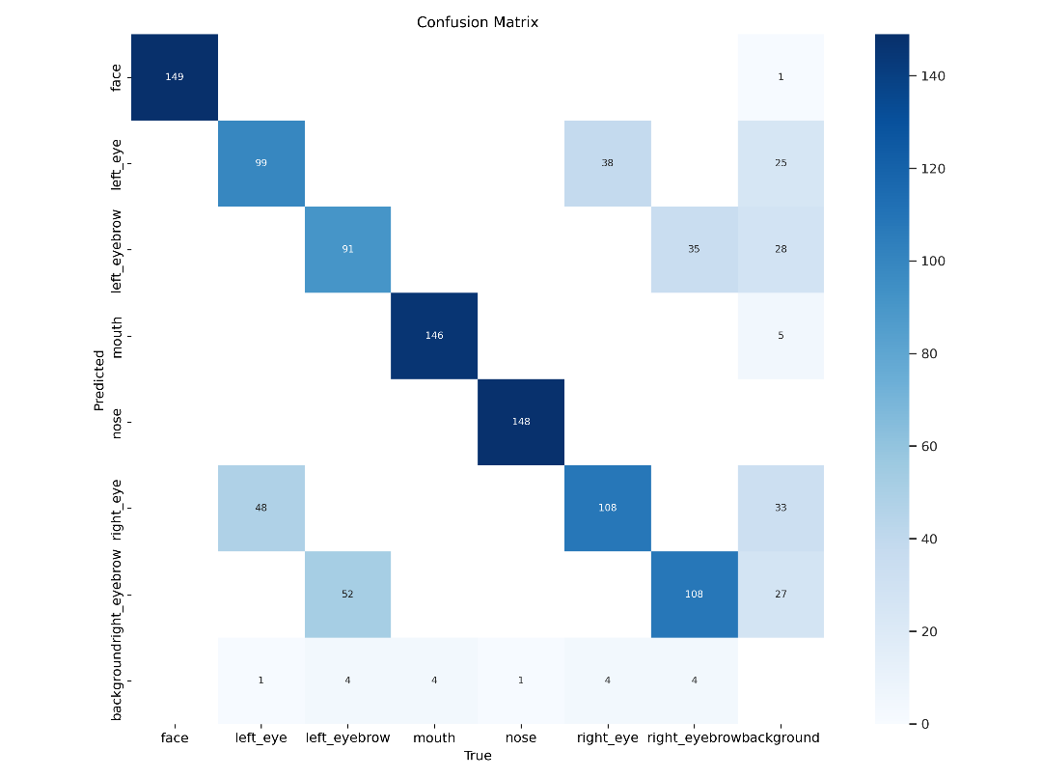

**Next Steps.**

To further improve the performance and capabilities of the facial feature detection system, the following steps are recommended:

1. **Enhance Dataset Diversity:** As a primary focus, consider expanding the training dataset to include faces captured from various angles, crowded scenes, diverse lighting conditions, and individuals of different ages and genders. This broader dataset can better prepare the model for real-world complexities and challenges, ultimately resulting in more accurate and robust feature detection.
2. **Iterative Data Collection:** Continuously collect and curate data to ensure that the model remains up-to-date and capable of handling evolving scenarios. Incorporate new images and variations as they become available, allowing the model to adapt and improve over time.
3. **Data Augmentation Strategies:** Implement advanced data augmentation techniques, such as geometric transformations, color adjustments, and noise addition. These strategies help augment the dataset further, providing the model with a richer set of examples for training.
4. **Regular Model Evaluation:** Establish a routine for model evaluation to monitor its performance over time. Regular assessments can identify areas where the model's accuracy may degrade due to evolving data patterns or challenges. These evaluations can guide model retraining and fine-tuning.
5. **Transfer Learning and Pre-trained Models:** Explore the use of transfer learning with pre-trained models to leverage the knowledge acquired from large-scale datasets. Fine-tuning a pre-trained model on your specific task can significantly expedite the training process and enhance performance.
6. **Model Architecture Optimization:** Continuously investigate alternative model architectures, such as those tailored for facial feature detection. Experiment with architectures that have excelled in similar tasks, as well as those designed to address challenges specific to facial feature recognition.
7. **Hyperparameter Tuning:** Fine-tune the model's hyperparameters, such as learning rates and batch sizes, to optimize its performance. This process involves systematic experimentation to identify the ideal configuration for your specific problem.
8. **Ensemble Techniques:** Consider ensemble techniques that combine predictions from multiple models to enhance overall accuracy. Combining the strengths of different models can result in more robust predictions.
9. **Real-time Application Integration:** If the facial feature detection system is intended for real-time applications, optimize model inference and processing speed. Ensure that the system can deliver results within acceptable time frames for the intended use cases.
10. **User Feedback Integration:** Collect user feedback and incorporate it into the model's improvement cycle. User insights can provide valuable guidance on areas where the system may require adjustments to better align with real-world needs.

These next steps encompass a holistic approach to ongoing model improvement, data quality enhancement, and adaptation to evolving challenges. By regularly iterating through these steps, we can maintain and further enhance the precision and robustness of your facial feature detection system.